|  |  |
| --- | --- |
| 77729699 | http://ytlx.whrsm.ac.cn/EN/1000-7598/current.shtml |

Go to the website using the based URL

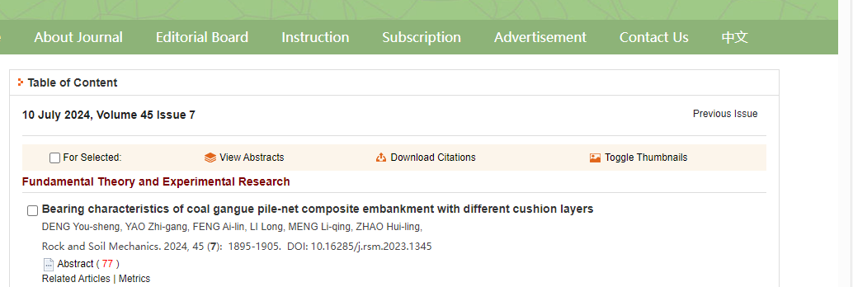

PAGE RANGE

DOI

Capture and click article title

issue

Date

year

volume

Month

After clicking article title you will get article page like below.

Click here to dowload pdf

Need both non roman and English TOC for this